**CFA 1 Review**

**Unit 1- Science Safety and Scientific Method**

*What lab safety precautions would be taken when dissecting preserved specimens?*

*What equipment would the biologist need to conduct an investigation with bacteria?*

*The scientist discovers that the experiment does not support the claim. What should the scientist do?*

**Be familiar with the following terms:**

Control

Data

Dependent variable

Experiment

Hypothesis

Independent variable

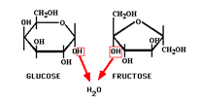Scientific Theory

Valid Conclusion

**Unit 2- Biochemistry**

*What are the functions of carbohydrates?*

*What are the functions of lipids?*

*What are the functions of nucleic acids?*

*What elements make up protein?*

*How do enzymes affect chemical reactions?*

**Be familiar with the following terms:**

Activation energy

Active site

Amino acid

Benedict’s solution

Biuret reagent

Carbohydrate

Catalyst

Dehydration synthesis (condensation)

Disaccharide

Enzyme (know processes and parts)

Fatty acid

Glycerol

Hormone

Iodine

Lipid

Monomoers

Nucleic acid

Organic compounds

Peptide bond

Polymers

Polysaccharide

Product

Protein

Reaction rate

Starch

Substrate

Sugar

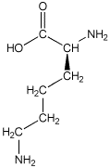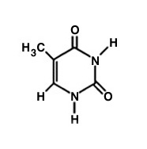Identify each molecule below as either a carbohydrate, a lipid, a nucleic acid or a protein.

Describe the processes illustrated below

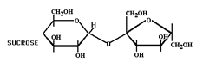1.



2.



3.