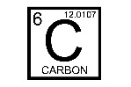
Organic substances must contain carbon.

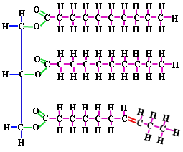
Lipids: fats, oils, waxes
- monomers are fatty acids
- made of the elements C,H,O
- major functions include
  - insulation
  - structural components of cell membrane
  - stores energy for slow release
- hydrophobic
- Saturated (butter)/Unsaturated Fats (oil)
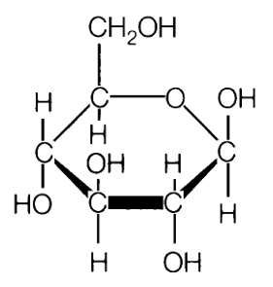
Carbohydrates: bread, pasta, rice
- monomers are saccharides (monosaccharides)
- made of elements C,H,O
- major functions of include
  - quick energy/ short term
  - regulation of blood sugar
Proteins
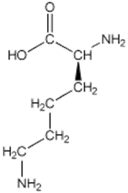
- monomers are amino acids
- made of elements C,H,O,N
- major functions include
  - Antibodies help defend against disease and fight infections.
  - Forms bones, muscles, hair and nails.
  - Shapes determine functions
- Carboxyl group is present
- Amino group is present
- R-group is present

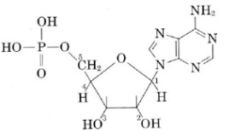
Nucleic Acids
- Monomers are nucleotides
- Made of elements C,H,O,N,P
- Major functions include
  - Storing genetic information
  - Basic instructions for living things
  - Helps make protein
- Two types DNA, RNA
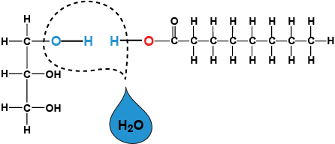
Dehydration synthesis: When monomers combine with each other (bond) to form larger molecules known as polymers, monomers release water molecules (H2O) as byproducts.

Enzymes: speeds up chemical reactions
Substrate
Active site
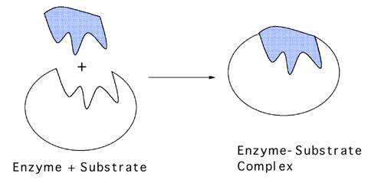
- Type of protein
- Is recycled after a reaction
- Lowers activation energy of a reaction

Enzyme

Steps of an Enzyme- Substrate Reaction
1. An enzyme and a substrate are in the same area.
2. The enzyme grabs onto the substrate with a special area called the active site. The active site is a specially shaped area of the enzyme that fits around the substrate. The active site is the keyhole of the lock.
3. A process called catalysis happens. Catalysis is when the substrate is changed. It could be broken down or combined with another molecule to make something new.
4. The enzyme lets go. Big idea. When the enzyme lets go, it returns to normal, ready to do another reaction. The substrate is no longer the same. The substrate is now called the product.

Unit 1- Science Safety and Scientific Method
What lab safety precautions would be taken when dissecting preserved specimens?
What equipment would the biologist need to conduct an investigation with bacteria?
The scientist discovers that the experiment does not support the claim. What should the scientist do?
Be familiar with the following terms:
Control
Data
Dependent variable
Experiment
Hypothesis
Independent variable
Scientific Theory
Valid Conclusion

