1st Semester Review

****Know the following terms:

**Label each of the biomolecules below. What process makes a chain of A? What process makes the monomer of B?**

* Carbohydrates

A

* Lipids
* Proteins
* Nucleic Acids
* Enzymes
* Hypotonic
* Hypertonic

B

* Isotonic
* Prokaryotic

**I.D. the process occurring at A and B above.**

* Eukaryotic
* Photosynthesis

Label the phases of mitosis below

* Cellular Respiration
* Mitosis
* Diploid
* Prophase
* Metaphase
* Anaphase
* Telophase
* S Phase
* DNA & RNA
* Adenine & Thymine
* Cytosine & Guanine
* Codon
* Protein Synthesis

What are the genotypes in the boxes below? What will the genotypic and phenotypic ratios be if B - Brown hair and b - blonde hair?

* Meiosis
* Haploid
* Dominant & Recessive
* 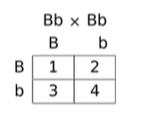Genotype & Phenotype
* Homozygous & Heterozygous

****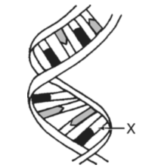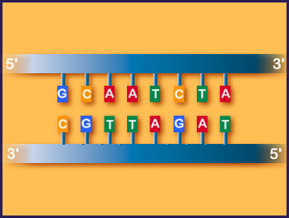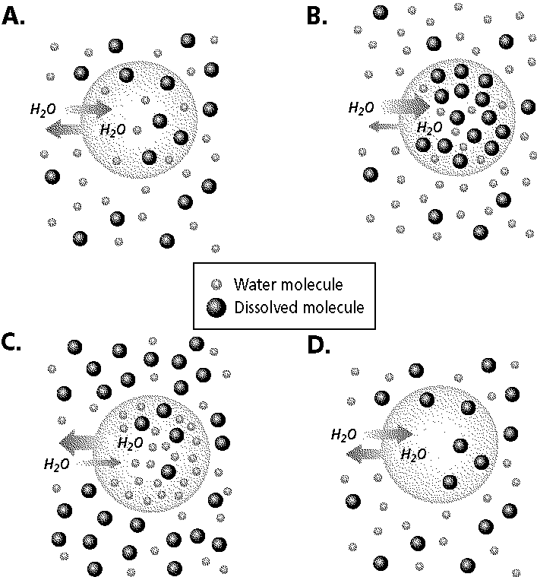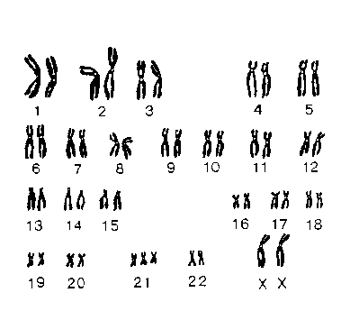

What is the diagram above depicting? Label X. If X were Thymine what would be its pair?

Is the karyotype below normal or abnormal? If abnormal, how and what disease does it cause?

What biomolecule is shown above?

Transcribe the above DNA sequence.

**Label diagrams A-D as hypertonic, hypotonic or isotonic.**

**Describe what would happen each cell.**